H2 CHEMISTRY

SUMMARY

OF

NOTES

Chong Pin Shin
19J13 13
Topic 1 Atoms, Molecules, Stoichiometry & Redox
- Definitions
Isotopes refer to atoms of the same element with the same number of protons but different number of neutrons.

Relative atomic/isotopic mass $(A_{r})$ refers to the mass of one mole of atoms of an element/isotope relative to $\frac{1}{12}$ the mass of one mole of ${}_{ }^{12}C$ atoms.

Relative molecular mass $(M_{r})$ refers to the mass of one mole of molecules relative to $\frac{1}{12}$ the mass of one mole of ${}_{ }^{12}C$ atoms.

Relative formula mass $(M_{r})$ refers to the average mass of one formula unit of one mole of compound relative to $\frac{1}{12}$ the mass of one mole of ${}_{ }^{12}C$ atoms.

Note: All relative masses are ratios and have no units.
One mole of a substance contains exactly $6.02×{10}^{23}$ number of elementary entities.

Empirical formula shows the simplest whole-number ratio of the number of atoms of each element present in the substance

Molecular formula shows the actual number of atoms of the different elements in one molecule of the compound.

Eudiometry
$$C_{x}H_{y}+\left(x+\frac{y}{4}\right)O_{2}→xCO_{2}+\frac{y}{2}H_{2}O$$
On cooling, water vapor condenses leaving $CO_{2}$ and excess $O_{2}$ behind.
Gases are then shaken with aqueous potassium hydroxide/ any bases to absorb $CO_{2}$ leaving only excess $O_{2}$ behind.
Volumetric analysis
Equivalence point is the point during titration at which stoichiometric amounts of reactants have reacted.
It is independent of the indicator used.

End-point is the point during titration when the indicator changes colour.
May occur before/at/after equivalence point.

Acid-base titration
Indicator | $pH$ range | End-point | Colour below working $pH$ | Colour above working $pH$
Methyl orange | $$pH 3-5$$ | Strong acid added to base: Orange | Red | Yellow
 |  | Strong base added to acid: Orange
Screened methyl orange | $$pH 3-5$$ | Strong acid added to base: Grey | Violet | Green
 |  | Strong base added to acid: Grey
Thymolphthalein | $$pH 8-10$$ | Strong acid added to base: Colourless | Colourless | Blue
 |  | Strong base added to acid: Pale pink
Thymol blue | $$pH 8-10$$ | Strong acid added to base: Yellow | Yellow/  Red | Blue
 |  | Strong base added to acid: Blue

Redox
Disproportionation is a redox reaction in which one species is simultaneously oxidised and reduced.

Balancing equations
Under alkaline medium, follow:
- Balance All elements
- Balance Oxygen by adding $H_{2}O$
- Balance Hydrogen by adding $H^{+}$
- Neutralize $H^{+}$ by adding $OH^{-}$ to both sides of the equation
- Balance Charges by adding $e^{-}$
Under acidic/neutral medium, follow:
- Balance All elements
- Balance Oxygen by adding $H_{2}O$
- Balance Hydrogen by adding $H^{+}$
- Balance Charges by adding $e^{-}$
Common redox titrations
- Manganate (VII) titrations
- Manganate (VII) ion is a powerful oxidising agent.
- In acidic medium, manganate (VII) ion, ${MnO_{4}}^{-}$ is reduced to manganese (II) ion, ${Mn}^{2+}$.
$${MnO_{4}}^{-}+H^{+}+5e^{-}→{Mn}^{2+}+4H_{2}O$$
- Instead of nitric acid or hydrochloric acid, sulfuric acid is used to provide the acidic medium. This is because nitric acid is an oxidising agent itself while hydrochloric acid can be oxidised by ${MnO_{4}}^{-}$.
- No indicator is needed. Colour changes from colourless to pale pink.

- Dichromate (VI) titrations
- Dichromate (VI) ion is a weaker oxidising agent than Manganate (VII) ion, hence can only be used to oxidise a limited variety of reducing agents.
- In acidic medium, dichromate (VI) ion, ${{Cr}_{2}O_{7}}^{2-}$ is reduced to chromium (III) ion, ${Cr}^{3+}$
$${{Cr}_{2}O_{7}}^{2-}+14H^{+}+e^{-}→2{Cr}^{3+}+7H_{2}O$$
- No indicator is needed. Colour changes from orange to green.

- Iodine-thiosulfate titrations
- Thiosulfate ion ${S_{2}O_{3}}^{2-}$ is a common reducing agent for iodine.
$I_{2}+{S_{2}O_{3}}^{2-}→2I^{-}+{S_{4}O_{6}}^{2-}$
- Starch indicator is used. Colour changes from dark blue to colourless.
- Starch indicator is used near the end-point of the reaction when the solution is pale yellow, to avoid unreacted iodine forming starch-iodine complex with starch. Without indicator, solution turns from pale yellow to colourless.
Topic 2 Atomic Structure
- Definitions
Isoelectronic refers to atoms or ions with the same number of electrons.
Isotonic refers to atoms or ions with the same number of neutrons.

$n$, or the principal quantum number is used to indicate the energy levels of each quantum shell.

Behaviour in an electric field
Protons are deflected towards the negatively charged plate.
Electrons are deflected towards the positively charged plate. They are much lighter and hence are deflected to a larger extent.
$$Extent of deflection∝\frac{charge}{mass}$$

Special cases when filling 3d orbitals
When filling 3d orbitals, half or fully occupied d subshells tend to be more stable.
$${}_{24}^{ }{Cr}:1s^{2}2s^{2}2p^{6}3s^{2}3p^{6}3d^{5}4s^{1}$$
$$\boxed{↿⇂} \boxed{↿⇂} \boxed{↿⇂}\boxed{↿⇂}\boxed{↿⇂} \boxed{↿⇂} \boxed{↿⇂}\boxed{↿⇂}\boxed{↿⇂} \boxed{↿}\boxed{↿}\boxed{↿}\boxed{↿}\boxed{↿} \boxed{↿}$$
$${}_{29}^{ }{Cu}: 1s^{2}2s^{2}2p^{6}3s^{2}3p^{6}3d^{10}4s^{1}$$
$$\boxed{↿⇂} \boxed{↿⇂} \boxed{↿⇂}\boxed{↿⇂}\boxed{↿⇂} \boxed{↿⇂} \boxed{↿⇂}\boxed{↿⇂}\boxed{↿⇂} \boxed{↿⇂}\boxed{↿⇂}\boxed{↿⇂}\boxed{↿⇂}\boxed{↿⇂} \boxed{↿}$$
Ionisation energy
Ionisation energy is the energy required to remove 1 mole of electrons from 1 mole of gaseous atoms or ions.

Factors affecting ionisation energy
- Effective nuclear charge, $Z_{eff}$
- Refers to the net attractive force of the nucleus on the valence electrons after taking into account shielding effect.
- Effective nuclear charge is dependent on: nuclear charge and shielding effect.

- Atomic radius
- Refers to the size of the atom
- Atomic radius is dependent on number of filled principal quantum shells and effective nuclear charge.
Trends of $1^{st}$ ionisation energy
Trends of $1^{st}$ ionisation energy (IE) across a Period
- The $1^{st}$ IE generally increases across a Period.
- Across a period, nuclear charge increases while there is negligible increase in shielding effect as electrons are removed from the same shell. Hence, effective nuclear charge increases.
- The atomic radius also decreases.
- Therefore, valence electrons are more strongly attracted to the nucleus and more energy is required to remove the valence electron.
Trends of $1^{st}$ ionisation energy (IE) down a Group
- The $1^{st}$ IE generally decreases down a Group.
- Down a Group, increase in number of inner principal quantum shells increases shielding effect, which cancels out most of the increase in nuclear charge, causing effective nuclear charge to decrease.
- The atomic radius also increases.
- Hence, valence electrons are less strongly attracted to the nucleus and more energy is required to remove the valence electron.
Topic 3 Chemical Bonding
Chemical bonds
Electronegativity increases across a period and decreases down a group.

Electronegativity of an atom is a measure of its ability to attract electrons in a bond.
Chemical bonds are electrostatic forces of attraction.

Large difference in electronegativity: Ionic bond
Small or no difference: Covalent bond OR Metallic bond
Ionic Bonds
Ionic bonds are strong electrostatic forces of attraction between positively charged ions and negatively charged ions.

Ionic bonds are found extensively throughout the structure and are non-directional.
Ionic compounds are said to have a giant ionic lattice structure.
Number of oppositely-charged ions surrounding an ion is known as the coordination number.
Factors affecting strength of ionic bonds
- Charges of the cations and anion
- Ionic radii of the cations and anions.
Lattice energy is the energy released when one mole of solid ionic compound is formed from its constituent gaseous ions under standard conditions.

$$Magnitude of lattic energy \left(LE\right)∝\left|\frac{Z^{+}×Z^{-}}{r^{+}+r^{-}}\right|$$
Where, Z is the charge of the ions
r is the ionic radius

Ionic bonds formed between ions with high charge and small size will be strongest.

Covalent bond
Covalent bonds are strong electrostatic forces of attraction between the nuclei of each atom for the shared pairs of electrons (known as bond pair).

Bond length is the distance between the nuclei of atoms involved in a covalent bond.

Formations of bonds
1. $σ Sigma bond$
A bond formed when orbitals overlap head-on/ collinearly.

2. $π Pi bond$
A bond formed when orbitals overlap sideways/ collaterally. Found in molecules with double and triple bonds

Note: Only p-orbitals can form $π bonds.$

Single bond – 1 $σ bond$
Double bond – 1 $π bond$ 1 $σ bond$
Triple bond – 2 $π bond$ 1 $σ bond$
Due to more effective overlap of orbitals in $σ bonds$ compared to a $π bonds$, a $σ bond$ is stronger than a $π bond$.
Dative bonds
Dative bonds are covalent bonds formed when an atom donates a lone pair of electrons into an empty orbital of an electron deficient atom for sharing.

Dimerization is the process where monomers form dative bonds with each other to give rise to a dimer.

Factors affecting strength of covalent bonds
Strength of covalent bonds can be deduced from the energy required to overcome the bond.
Bond dissociation energy is the enthalpy change when one mole of a particular covalent bond between atoms in gaseous molecule is broken.

1. Effectiveness of orbital overlap
The larger the size of bonding atoms, the larger and more diffused the valence orbitals and hence the less effective the overlap of orbitals and the weaker the covalent bonds.
2. Bond multiplicity/ order
$$Single bond <Double bond<Triple bond$$
3. Polarity of the bond
Polar bond arises when atoms forming covalent bonds have a difference in electronegativity.
Electron density is drawn towards the more electronegative element.

Valence Shell Electron Pair Repulsion (VSEPR) Theory
Principles
1. Electron pairs are arranged as far as possible to minimise repulsion.
2. $Lone pair-lone pair repulsion>Bond pair-lone pair repulsion>Bond pair-bond pair repulsion$

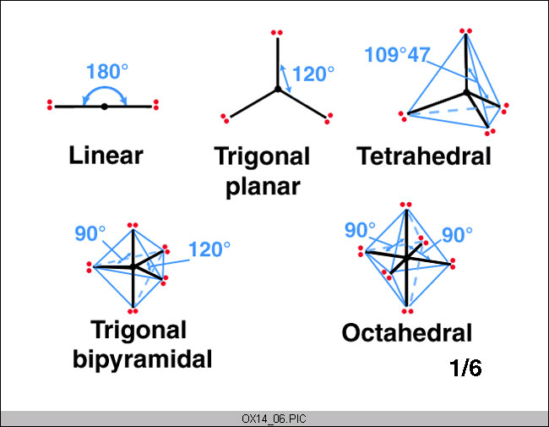
Intermolecular forces
1. Permanent dipole-permanent dipole (pd-pd) Interactions
Permanent dipole-permanent dipole interactions are weak electrostatic forces of attractions that occur between polar molecules.

The larger the magnitude of the net dipole moment, the stronger the permanent dipole-permanent dipole interactions.
2. Instantaneous dipole-induced dipole (id-id) Interactions
Note: Instantaneous dipole-induced dipole interactions do not just occur between non polar molecules.
Instantaneous dipole-induced dipole interactions are weak electrostatic forces of attraction that occur between non-polar molecules.

Strength of instantaneous dipole-induced dipole interactions depends on number of electrons in the molecule.
Extensiveness of instantaneous dipole-induced dipole interactions depends on the surface area of the molecule.
3. Hydrogen bonds
H – S/F/O/N
Hydrogen bonds are weak electrostatic forces of attraction between the protonic hydrogen of one molecule with a lone pair on a highly electronegative atom of another molecule.

Strength of hydrogen bonds depends on the polarity of the H-X bond.
$$H-F>H-O>H-N$$
Dimerization usually occurs when carboxylic acids are in liquid and solids states. If dissolved in water, due to the large amount of water molecules, the hydrogen bonds are formed between the acid molecules and water molecules instead. Hence, when dissolved in water, acids usually have half of the $M_{r}$ of when in pure liquid state.
Topic 4 Gaseous State
Kinetic Theory of Matter
Assumptions:
1. The gas particles have negligible volume/size compared to the volume of the container.
2. The gas particles exert negligible intermolecular forces on one another.
Three Gas Laws
Boyle’s Law
$$p_{1}V_{1}=p_{2}V_{2}$$

When temperature is constant, $pV=k$
Charles’ Law
$$\frac{V_{1}}{T_{1}}=\frac{V_{2}}{T_{2}}$$

$$Volume∝\frac{1}{Pressure}$$

When pressure is constant, $\frac{V}{T}=k$
$$Volume∝Temperature$$
Avogadro’s Law states that at constant temperature and pressure, the volume of a gas is directly proportional to the number of moles of the gas.
$$\frac{V_{1}}{n_{1}}=\frac{V_{2}}{n_{2}}$$

$$p_{total}=p_{A}+p_{B}+p_{C}+…$$
$$Sub n=\frac{m}{M},$$
$$M=\frac{mRT}{pV}$$

$$density ρ=\frac{pM}{RT}$$

Topic 5 Chemical Energetics (Part I)
Enthalpy is the measure of energy content of the substance.

$$Heat evolved, Q=mc∆θ$$

Standard enthalpy change
Standard enthalpy change of Reaction is the enthalpy change when molar quantities of reactant, as specified by the balanced chemical equation, react to form products under standard conditions.

A thermochemical equation is a balanced stoichiometric equation, including state symbols, of the reaction with the $∆H$ value.

Standard enthalpy change of Atomisation of an element is the enthalpy change when one mole of gaseous atoms is formed from the element in its standard state under standard conditions.
*$∆H$ always positive.

Standard enthalpy change of Formation of a substance is the enthalpy change which occurs when one mole of the substance is formed from its constituent elements in their standard states under standard conditions.

Standard enthalpy change of Combustion of a substance is the enthalpy change when one mole of the substance is completely burnt in oxygen under standard conditions.

*$∆H$ always negative.

Standard enthalpy change of Neutralisation is the enthalpy change when one mole of water is formed from the reaction of an acid and an alkaline under standard conditions.

Standard enthalpy change of Hydration of an ion is the enthalpy change when one mole of gaseous ion is hydrated under standard conditions.

Standard enthalpy change of Solution of a substance is the enthalpy change when one mole of the substance is completely dissolved to give an infinitely dilute solution under standard conditions

Ionisation Energy
First ionisation energy of an element is the enthalpy change when one mole of electrons is removed from one mole of gaseous atoms.

Second ionisation energy of an element is the enthalpy change when one mole of electrons is removed from one mole of gaseous, singly charged cations of the element.

Electron Affinity
First electron affinity of an element is the enthalpy change when one mole of gaseous atoms accepts one mole of electrons.

Second electron affinity of an element is the enthalpy change when one mole of gaseous, singly charged anions accepts one mole of electrons.

Lattice Energy
Lattice energy is the enthalpy change when one mole of the solid ionic compound is formed from its constituent gaseous ions under standard conditions

$$Magnitude of LE∝\left|\frac{Z^{+}×Z^{-}}{r^{+}+r^{-}}\right|$$

Bond Dissociation Energy/ Bond Energy
Bond energy is the average enthalpy change when one mole of covalent bonds between atoms in gaseous molecules is broken.
*Always positive

Hess’ Law states that the enthalpy change of a chemical reaction only depends on the initial and final states of the system and is independent of the pathway taken.

Topic 6 Chemical Energetics (Part II)
Entropy is a measure of the disorder in a system.
Entropy is the measure of how probable is the state of the system.

Ways to increase entropy
1. Increase in temperature
When temperature increases → average kinetic energy of the molecules increases → more ways to distribute more quanta of energy within the system → increase in entropy
2. Change in phase
When there is a change in phase → orderly arrangement of particles is destroyed → more ways to arrange the particles → increase in disorder → increase in entropy
3. Reaction leading to increase in number of gaseous particles
Increase in number of gaseous particles → more particles move randomly in all directions → increase in disorder → increase in quanta
4. Mixing of particles
Mixing of particles → more ways to arrange the particles in a larger volume → increase in disorder → increase in entropy
5. Gas expansion in volume
Gas expansion → more ways for gas particles to arrange themselves in a larger volume → increase in entropy
Gibbs Free Energy
${∆G}^{⦵}<0$, reaction is spontaneous.
Standard Gibbs free energy change of reaction can be defined as
$${∆G}^{⦵}={∆H}^{⦵}-T{∆S}^{⦵}$$
If ${∆G}^{⦵}>0$, reaction is not spontaneous.
${∆G}^{⦵}=0$, reaction is at equilibrium.
Topic 7 Reaction Kinetics
Rate of reaction
The rate of reaction is defined to be that of the change in concentration of reactant or product per unit time.
Initial rate is the reaction rate at the start of the reaction when an extremely small amount of reactant has been used up.

Obtained by determining the gradient of tangent drawn at $t=0$.
$$Average rate=-\left[\frac{{\left[reactant\right]}_{t2}-{\left[reactant\right]}_{t1}}{t_{2}-t_{1}}\right]=\left[\frac{{\left[product\right]}_{t2}-{\left[product\right]}_{t1}}{t_{2}-t_{1}}\right]$$

Rate equation
The rate equation is the experimental relationship between the reaction rate and the concentration of the reactants.

Order of reaction
The order of reaction is the power of the reactant’s concentration term in the experimentally-determined rate equation.

$$rate=k{[A]}^{m}{[B]}^{n}$$
The reaction is said to have an overall order of $(m+n)$.
Rate constant
Rate constant increases when temperature increases and $E_{a}$ decreases.
$$Unit of k=\frac{unit of rate}{{( mol {dm}^{-3})}^{(m+n)}}$$
The rate constant is the proportionality constant in the experimentally determined rate equation.

Half-life
For a first-order reaction, half-life is constant.
Half-life, $t_{1/2}$ represents the time taken for concentration of a reactant to be halved.
$$t_{1/2}=\frac{\ln{2}}{k}$$
For second-order reaction, half-life increases with time.
Pseudo-order reaction
When one of the reactant is present in large excess with respect to the other reactants, the reaction becomes independent of the reactant and is known as a pseudo-order reaction.
Determining rate constant
$$A+B→C+D$$
$$rate=k{[A]}^{m}{[B]}^{n}$$

- Inspection method
To find m,
Comparing two experiments where [B] is kept constant,
when [A] doubles, the rate doubles/quadruples.
Hence, rate is directly proportional to A and rate of reaction is first-order/second order with respect to A.

- Substitution method
To find m,
[B] is kept constant in experiment 1 and 2,
$$\frac{{(rate)}_{1}}{{(rate)}_{2}}={\left(\frac{{[A]}_{1}}{{[A]}_{2}}\right)}^{m}$$

- Graphical method
Case 1.
Concentration vs Time graph is a straight line, $rate of reaction=-gradient=k$
Rate of reaction is zero-order with respect to A.
Case 2.
Concentration vs Time graph is a curve,
a) Half-life is constant,
Rate of reaction is first-order with respect to A.
b) Half-life is not constant,
Plot $\frac{1}{[A]}$ against Time graph.
If graph is straight line, reaction is second-order with respect to A.

Reaction rates
Collision Theory states that the reactant particles must collide effectively before they can react.
An reaction will only occur when particles collide with:
1. Activation energy
2. The appropriate collision geometry

Topic 8 Chemical Equilibria
Reversible Reactions
Reversible reaction is one that can go in both the forward and backward directions
Dynamic equilibrium refers to a reversible process at equilibrium in which the rate of forward reaction is equal to the rate of backward reaction.

$$aA+bB⇌cC+dD$$
*Solids are excluded
$Equilibrium constant$ relates
$$K_{c}=\frac{{\left[C\right]}^{c}{\left[D\right]}^{d}}{{\left[A\right]}^{a}{\left[B\right]}^{b}}$$
$$Unit of K_{c}={(mol {dm}^{-3})}^{c+d-a-b}$$

$$Equilibrium constant, K_{p}=\frac{{P_{C}}^{c}{P_{D}}^{d}}{{P_{A}}^{a}{P_{B}}^{b}}$$
$$Unit of K_{c}={(Pa/atm)}^{c+d-a-b}$$

Equilibrium constant is only affected by temperature
Catalyst does not affect the equilibrium constant, but how fast equilibrium is reached
If equilibrium constant is large $⇒$ high proportion of products $⇒$ position of equilibrium lies to the far right
If equilibrium constant is small $⇒$ high proportion of reactants $⇒$ position of equilibrium lies to the far left
$$Reaction quotient, Q_{c}=\frac{{\left[C\right]}^{c}{\left[D\right]}^{d}}{{\left[A\right]}^{a}{\left[B\right]}^{b}}$$

$$Qc<Kc$$ | $$Qc=Kc$$ | $$Qc>Kc$$
- Forward reaction is favoured  - Position of equilibrium shifts right | - System is at equilibrium  - No shifting of position of equilibrium | - Backward reaction is favoured  - Position of equilibrium shifts left
Le Chatelier’s Principle
Le Chatelier’s Principle states that if a system at dynamic equilibrium is subjected to a change which disturbs the equilibrium, the system responds in such a way to counteract the effect of the change.

The position of equilibrium shifts right/left to favour the forward/backward reaction

Haber process
$$N_{2}\left(g\right)+3H_{2}\left(g\right)→2NH_{3}\left(g\right)$$
$$∆H=-92.4 kJ {mol}^{-1}$$
$$450℃$$
$$250 atm$$
Catalyst: Finely divided iron

Topic 9 Acid-Base Equilibria
Acid and Bases
Arrhenius theory
Acid is a compound that dissolves in water to yield hydrogen ions.
Base is a compound that dissolves in water to yield hydroxide ions.

Bronsted-Lowry Theory
Acid is a substance that can donate a proton to another substance.
Base is a substance that accept a proton from another substance.

Lewis theory
Acid is a substance that can accept a pair of electrons from a base to form a dative covalent bond.
Base is a substance that can donate a pair of electrons to form a dative covalent bond.

Degree of ionisation at the same temperature and concentration, indicates the relative strength of acids/bases.
$$α=\frac{amount of molecules which ionised at equilibrium}{amount of molecules present initially}$$

$pH$ and $pOH$
$$pH=-\lg{ [H^{+} (aq)]}$$
$$\left[H^{+} \left(aq\right)\right]={10}^{-pH}$$

$$pOH=-\lg{ [{OH}^{-} (aq)]}$$
$$\left[{OH}^{-} \left(aq\right)\right]={10}^{-poH}$$

Auto-ionisation of Water
$$Ionic product of water, K_{w}=\left[H^{+}\right]\left[{OH}^{-}\right]$$
At $25℃$, $K_{w}=1.00×{10}^{-14} {mol}^{2} {dm}^{-6}$
*$\left[H^{+}\right]=\left[{OH}^{-}\right]$

Units: $mol {dm}^{-3}$
$$HA \left(aq\right)+H_{2}O \left(l\right)⇌{H_{3}O}^{+} \left(aq\right)+A^{-}(aq)$$
$$Acid dissociation contant, K_{a}=\frac{\left[H^{+}\right]\left[A^{-}\right]}{\left[HA\right]}$$

Units: $mol {dm}^{-3}$
$$B \left(aq\right)+H_{2}O \left(l\right)⇌BH^{+} (aq)+{OH}^{-} (aq)$$
$$Base dissociation constant, K_{b}=\frac{\left[{BH}^{+}\right]\left[{OH}^{-}\right]}{\left[B\right]} NX DCF$$

Conjugate Acid-Base Pairs
$$K_{a}×K_{b}=K_{w} at 25℃$$
$$HA \left(aq\right)+B \left(aq\right)⇌{BH}^{+} \left(aq\right)+A^{-}(aq)$$
$$HA – Acid$$
$$B – Base$$
$${BH}^{+} - Conjugate acid$$
$$A- - Conjugate acid$$

ZXF
Weak Acids and Bases
*Use $K_{a}$ and $K_{b}$ to calculate $[H^{+}]$ and $[{OH}^{-}]$
$$B \left(aq\right)+H_{2}O \left(l\right)⇌BH^{+} (aq)+{OH}^{-} (aq)$$
$$Base dissociation constant, K_{b}=\frac{\left[{BH}^{+}\right]\left[{OH}^{-}\right]}{\left[B\right]}$$

Buffer Solutions
A buffer solution is one that can resist a change in $pH$ when a small amount of acid or base is added to it.

- Acidic buffer
- Alkaline buffer
$pH$ of buffer solution
$$pH=pK_{a}+\lg{\frac{\left[A^{-}\right]}{\left[HA\right]}}$$

$$pOH=pK_{b}+\lg{\frac{\left[{BH}^{+}\right]}{\left[B\right]}}$$

Buffering capacity
Buffering capacity is the amount of acid or base that may be added to a buffer solution before its $pH$ changes appreciably.

Buffer is most effective when:
- Amounts of weak acid/base and its conjugate are large relative to that of the acid/base to be added.
- $\left[HA\right]=\left[A^{-}\right]$ or $\left[B\right]={[BH}^{+}]$
Acid-Base titrations
The equivalence point is the point during a titration at which stoichiometric amounts of reactants have reacted.
The end-point is the point during titration when the indicator changes colour.

Topic 10 Solubility Equilibria
Units: $mol {dm}^{-3}$
Solubility of a substance is the maximum amount of the substance that will dissolve in a given volume of solvent at a specified temperature.

Soluble | Exceptions
All Group I metal (${Li}^{+}, {Na}^{+}, K^{+}, {Rb}^{+}, {Cs}^{+}$)  Ammonium (${NH_{4}}^{+}$) salts | Nil
All nitrates (${NO_{3}}^{-}$) | Nil
Most halides (${Cl}^{-}, {Br}^{-}, I^{-}$) | $${Ag}^{+}, {Pb}^{2+}, {Cu}^{+}$$
Most sulfates (${SO_{4}}^{2-}$) | $${Pb}^{2+}, {Ca}^{2+}, {Sr}^{2+}, {Ba}^{2+}$$

Sparingly soluble | Exceptions
Most oxides ($O^{2-}$) | Group I metal, ${NH_{4}}^{+}$, ${Ba}^{2+}$
Most hydroxides (${OH}^{-}$) | Group I metal, ${Ba}^{2+}$
Most carbonates & phosphates (${CO_{3}}^{2-} \& {PO_{4}}^{3-}$) | Group I metal, ${NH_{4}}^{+}$

$$A_{a}B_{b} \left(s\right)⇌aA^{b+}+bB^{a-}$$
$$Solubility product, K_{sp}={[A^{b+}]}^{a} {[B^{a-}]}^{b}$$

$$Ionic product, I.P.= {[A^{b+}]}^{a} {[B^{a-}]}^{b}$$

$$I.P.<K_{sp}$$ | $$I.P.=K_{sp}$$ | $$I.P.>K_{sp}$$
- Solution is not saturated.  - Precipitation does not occur | - Solution is saturated.  - Precipitation does not occur. | - Solution is saturated.  - Precipitation occurs.

Topic 11 Periodic Table

Topic 12 Introduction to Organic Chemistry
Formulas
- Empirical formula
- Shows the simplest whole number ratio of the number of atoms of each element in a compound
- Molecular formula
- Shows the actual number of atoms present in a compound
- Structural
- Shows the structure of an organic molecule with no ambiguity

  - Full structural formula/ Displayed formula
- ALL bonds must be shown

  - Condensed structural formula
- Shows the atoms without showing the bonds
- E.g. $CH_{3}CO_{2}H$, $C_{6}H_{5}OH$

  - Skeletal formula
- Omitting the $C$ atoms and $H$ atoms bonded to $C$

  - Stereochemical formula
- Shows the three-dimensional structure around the stereochemical center.
Functional groups and the Homologous series
Functional groups are composed of a group of atoms that give the molecule its chemical property.
Homologous series is a family of compounds containing the same functional group, in which each successive member increases by one $-CH_{2}-$ unit.
Down the homologous group, there is a gradual change in physical property and have similar chemical properties.

Types of organic reactions
- Addition
Addition reaction is when two substance react together to form a single product.

- Elimination
When a small molecule is removed/eliminated to from a larger one

- Substitution
It occurs when one atom or one group of atoms is substituted by another.

- Oxidation/Reduction
Oxidation: It occurs when oxygen is added or hydrogen is removed.
Reduction: It occurs when oxygen is removed or hydrogen is added.

- Condensation
When two molecules come together to form a bigger molecule with the elimination of a small molecule such as water or $HCl$.

- Hydrolysis
When a molecule is split into two by the action of water, often catalysed by dilute acids or dilute alkali.
Basic of reaction mechanism
- Electron movement
  - Homolytic fission
Splitting of a single bond to give an equal share of bonding electrons.
Homolytic fission often result in formation of radicals
  - Heterolytic fission
Splitting of a bond giving an unequal share of the bonding electrons

Topic 13 Alkanes
Alkanes are the least reactive of the homologous series found in organic chemistry. They are known to be saturated.
$$General formula= C_{n}H_{2n+2}$$

Isomerism
Alkane can exhibit structural isomerism and optical isomerism.
Physical properties
- Down the homologous series, boiling point and melting point increases
  - Down the series, the $Mr$ increases
  - The larger the $Mr$, the larger the electron cloud
  - The larger the electron cloud, the more easily it can be polarised
  - Hence, more energy is needed to overcome the stronger instantaneous-dipole induced dipole interactions between alkane molecule
*Straight-chained alkanes have higher boiling point than branched alkanes as there is larger surface for id-id to occur.
- Alkanes are soluble in non-polar solvents but insoluble in polar solvents ($H_{2}O$)
  - Favourable interactions can occur between alkanes and non-polar solvents (id-id)
Chemical properties
*Alkanes requires harsh conditions to react chemically due to the strong $C-H$ and $C-C$ bonds and alkane molecules being non-polar.
- Combustion
$$General equation: C_{x}H_{y}+\left(x+\frac{y}{4}\right)O_{2}→xCO_{2}+\frac{y}{2}H_{2}O$$

- Free radical substitution
Reagents and conditions: ${Cl}_{2}(g)$ or ${Br}_{2}(l)$, UV light or heat
Observation: Greenish-yellow chlorine gas decolorize, or Reddish-brown bromine decolorize
Initiation
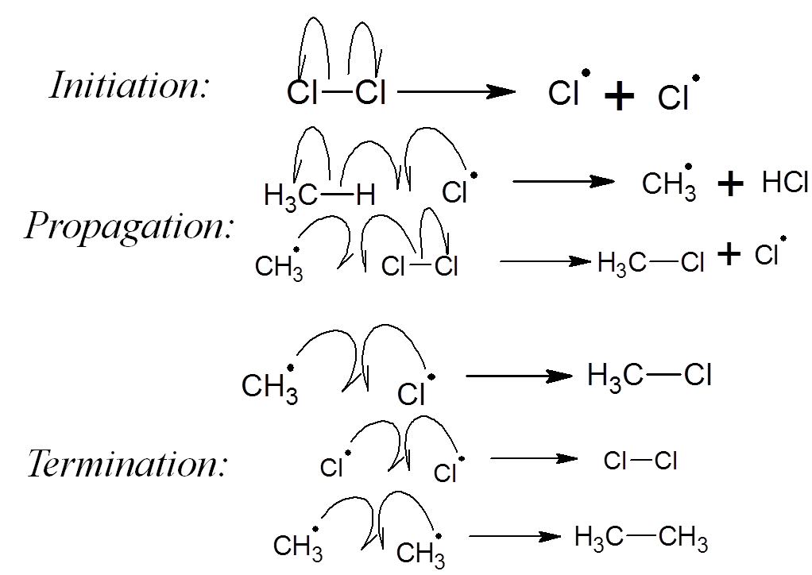
Propagation

Termination

*$Cl-Cl$ bond is homolytically broken to give two chlorine radicals.

*Since there is a radical produced at the end of any propagation step, the reaction is self-sustaining until the reactants are exhausted.
This makes the overall process a chain reaction and only limited UV light is needed to kickstart the reaction

Factors affecting product formation
Free radical substitution is not a good way to obtain alkyl halides as it is difficult to control the extent and position of the substitution.
- If halogen is in excess, further substitution can take place, resulting in a mixture of multi-substituted halogenoalkanes.

- Since all hydrogen atom on alkane are susceptible to substitution, the product will depend on the probability of forming the intermediates.
There are 3 different types of carbon in the molecule: Primary, Secondary, Tertiary.
Alkyls are electron donating while radicals are electron deficient. Hence, alkyls donate electron density to make radicals less electron deficient and more stable.
Radicals that are more stable are more readily formed.ko
Factors affecting the position of substitution
1. Ratio of different types of hydrogen present in the alkane
Used to find theoretical ratio.
2. Stability of radicals (Tertiary$>$Secondary$>$Primary)
Used to find actual ratio.
$$Actual ratio=relative stability of radicals×theoretical ratio$$
Rate determining step
Rate of free radical substitution is determined by the $H-X$ bond strength.
The stronger the $H-X$ bond, the more exothermic the reaction and the faster the rate of reaction.
Environmental consequences of burning alkanes
- $CO$ is a pollutant which binds irreversibly with haemoglobin in blood, resulting in the blood reduced capacity in carrying oxygen.
- Combustion of alkanes produces $CO_{2}$ which can lead to enhanced greenhouse effect.

Topic 14 Alkenes
Alkenes are unsaturated hydrocarbons that contain at least one $C=C$. They have fewer than the maximum possible number of hydrogen atoms.
If there is only one $C=C,$
$$General formula= C_{n}H_{2n}$$

Isomerism
Alkene can exhibit geometric isomerism due to the presence of a restrictive $C=C$ bond.
Physical properties
- Down the homologous group, boiling and melting point increases
  - Down the series, the $Mr$ increases
  - The larger the $Mr$, the larger the electron cloud
  - The larger the electron cloud, the more easily it can be polarised
  - Hence, more energy is needed to overcome the stronger instantaneous-dipole induced dipole interactions between alkane molecule
However, some alkenes have different boiling and melting point (bromoalkene, chloroalkene)
*Cis isomers have higher boiling point
The electron withdrawing effect of the substituent groups produces an overall dipole moment for the molecule, making the molecule polar. Hence, more energy is required to overcome the stronger permanent dipole-permanent dipole interactions between cis isomers than the instantaneous dipole-induced dipole interactions between trans isomers.
*Trans have higher melting point
Trans isomers have higher symmetry and hence it can be packed more efficiently than cis isomers. More energy is required to overcome the more extensive instantaneous dipole-induced dipole interactions in trans isomers.
Intermediate: Carbocation
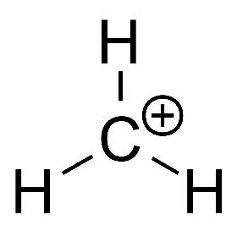
- Central C atom is positively charged and is $sp^{2}$ hybridised
- Due to its trigonal planar structure, nucleophiles can be attack from either side of the plane
- Different carbocations have different stability (Tertiary$>$Secondary$>$Primary)
  - With electron-donating substituents (alkyl groups), the positive charge on the central C atom is dispersed, stabilizing the carbocation.
  - With electron-withdrawing substituents (H atom), the positive charge on the central C atom is intensified, destabilizing the carbocation.

Chemical properties
- Reduction reaction
  - Addition of hydrogen (hydrogenation)
Reagents and conditions: $H_{2} \left(g\right)$
$Ni$, $Pd$ or $Pt$ catalyst
high temperature and pressure
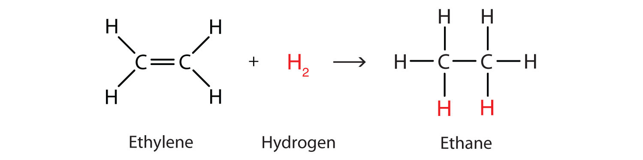

- Electrophilic addition
  - Electrophilic addition of hydrogen halides $H-X$
Reagents and conditions: $HCl \left(g\right)$, $HBr \left(g\right)$, $HI \left(g\right)$ at room temperature
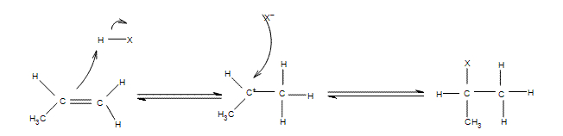
*Markovnikov’s Rule: In electrophilic addition, the electrophile adds in such a way that the most stable carbocation intermediate is formed.
*When a hydrogen halide is added such that an intermediate carbocation with 3 different groups is produced, a racemic mixture is formed as two equal amounts of enantiomers are formed. This is because the planar carbocation has equal chances of being attacked from the top or bottom, then having equal chances of producing two enantiomers.

  - Electrophilic addition of halogens $X_{2}$
Reagents and conditions: ${Cl}_{2} \left(g\right), {Br}_{2} \left(l\right)$ / ${Br}_{2}$ dissolved in $C{Cl}_{4}$
at room temperature in the absence of UV light
Observations: Greenish-yellow ${Cl}_{2}$ / Reddish-brown ${Br}_{2}$ decolourized
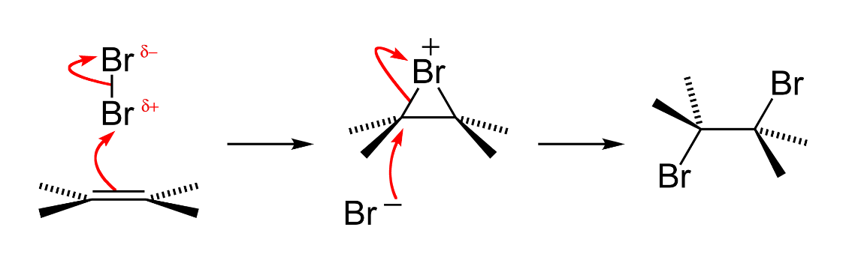

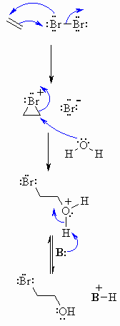
  - Electrophilic addition of bromine water ${Br}_{2} \left(aq\right)$
Reagents and conditions: ${Br}_{2} \left(aq\right), rtp$
Observation: Orange ${Br}_{2} (aq)$ decolourized

Water, being a nucleophile, in much higher concentration than bromide anion attacks the carbocation, forming bromoalcohol.

  - Electrophilic addition of steam $H_{2}O$
Reagents and conditions: Steam, $300℃$, $70 atm$, $H_{3}PO_{4}$ catalyst
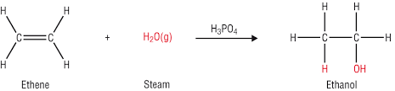

- Oxidation
  - Mild oxidation (formation of diol)
- Acidic conditions:
Reagents and conditions: $KMnO_{4}$, dilute sulfuric acid, cold
Observations: Purple $KMnO_{4}$ decolourized

- Alkaline conditions:
Reagents and conditions: $KMnO_{4}$, $NaOH (aq)$, cold
Observations: Purple $KMnO_{4}$ decolourized and brown precipitate of $MnO_{2}$ is formed

  - Strong oxidation (oxidative cleavage)
- Acidic conditions:
Reagents and conditions: $KMnO_{4}$, dilute sulfuric acid, heat
Observations: Purple $KMnO_{4}$ decolourized

- Alkaline conditions:
Reagents and conditions: $KMnO_{4}$, $NaOH (aq)$, heat
Observations: Purple $KMnO_{4}$ decolourized and brown precipitate of $MnO_{2}$ is formed
No. of H atoms on carbon | Structure | Products
2 | $$=CH_{2}$$ | $$CO_{2}+H_{2}O$$
1 | $$=CRH$$ | $$R-COOH$$  Carboxylic acid
0 | $$=CRR^{'}$$ | $$R-CO-R^{'}$$  Ketone
*Oxidative cleavage is a good way to distinguish between alkenes and terminal alkene.
Paper 4 Practical

